PROJECT REPORT
FJWU Campus Event & Student Engagement Control System
GROUPMEMBERS:
1. FATIMASABIR-034
2. MALAIKAAROOJ-057
3. MARIAYASMEEN-059
4. MARYAM-061
SUBMITTEDTO: Mam Qurat-ul-ain Majid
10 January, 2026

2. Abstract
The FJWU Event Hub is a comprehensive web application designed to streamline the management and discovery of university events at Fatima Jinnah Women University (FJWU). The system serves two primary user roles: Students and Managers. It allows Managers (society heads or faculty) to create, edit, and publish events, while enabling Students to browse, search, and register for these events. The application utilizes a modern technology stack comprising React.js for the frontend and Firebase for backend services, ensuring a responsive, real-time, and secure user experience.

3. Introduction
University campuses bustle with numerous activities ranging from academic seminars to cultural festivals. However, traditional methods of event promotion—such as physical notice boards or scattered social media posts—often lead to information asymmetry. Students may miss out on opportunities, and organizers may struggle to reach their target audience. The FJWU Event Hub was developed to bridge this gap by providing a centralized digital platform where all university events are listed, detailed, and easily accessible. The primary motivation is to enhance campus engagement and simplify the administrative burden of event coordination.

4. Project Scope
The scope of this project covers the end-to-end lifecycle of university events.
Included Functionalities:
* User Authentication (Login, Signup, Email Verification).
* Role-Based Access Control (Student vs. Manager).
* Event Management (Create, Update, Publish).
* Event Discovery (Feed, Search, Filtering).
* Profile Management for Students and Managers.
* Event Registration and Interest Tracking.
* Responsive User Interface for Desktop and Mobile.

Excluded Functionalities (Out of Scope):
* In-app payment processing for paid events.
* Real-time chat messaging between users (currently a placeholder).
* Advanced automated analytics (currently a placeholder).

5. Objectives of the Application
The main objectives of the FJWU Event Hub are:
* Centralization: To gather all university event information in a single, accessible repository.
* Efficiency: To reduce the time and effort required for organizers to publicize events.
* Accessibility: To ensure students can easily find events relevant to their interests and schedule.
* Security: To restrict access to verified university affiliates using official email addresses.

6. Target Users
The system is designed for two distinct user groups:
* Students: The primary consumers of content. They use the application to view upcoming events, track their registrations, and manage their personal profiles.
* Event Managers: The content creators. These are typically society presidents, department heads, or administrative staff responsible for organizing and publishing events. They have privileged access to create and edit event details.

7. Technology Stack
The application is built using a modern, robust tech stack:
* Frontend Framework: React.js (v19) with Vite for fast build and development performance.
* Styling: Tailwind CSS for a utility-first, responsive design system.
* Backend & Database: Firebase Firestore (NoSQL database) for storing user and event data.
* Authentication: Firebase Authentication for secure email/password login and identity management.
* File Storage: Firebase Storage for hosting event banners and user profile pictures.
* Routing: React Router DOM (v7) for handling client-side navigation.
* Icons: Lucide React for consistent and scalable UI icons.

8. System Architecture
The system follows a client-server architecture, specifically leveraging a serverless model via Firebase.
* Frontend (Client): The React application runs in the user's browser, handling the UI, state, and user interactions.
* Backend (Service): Firebase acts as the Backend-as-a-Service (BaaS). It handles API requests for data retrieval, authentication verification, and file storage.
* Database: Firestore stores data in a document-oriented structure (Collections: users, events).
* Interaction: The client communicates directly with Firebase SDKs, removing the need for a traditional intermediate REST API server for most operations.

9. Application Workflow
The typical user journey is as follows:
1. Landing: A user arrives at the landing page.
2. Authentication: The user logs in or signs up. New users must verify their university email (@fjwu.edu.pk) before accessing the system.
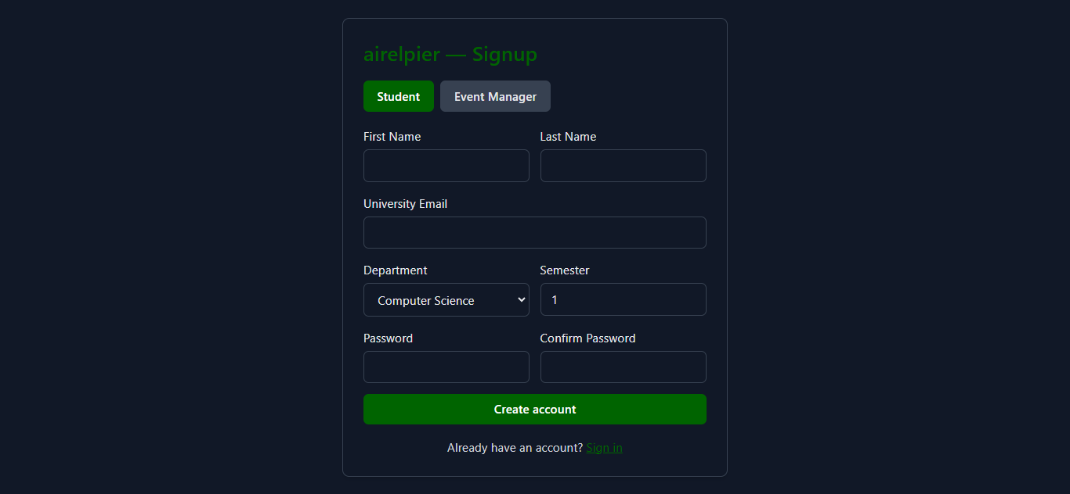
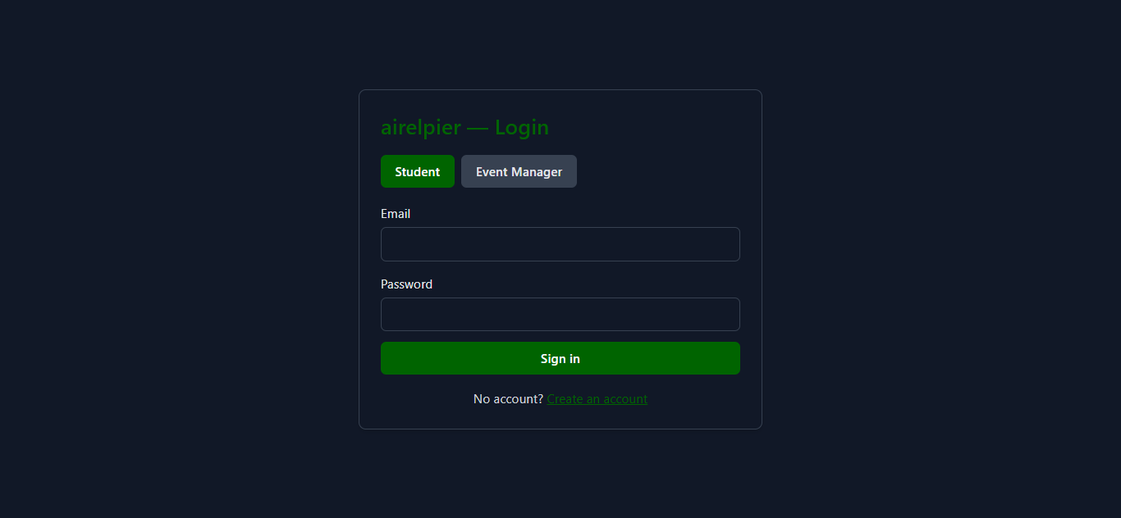
- Login Screen: This is the primary entry point for existing users. It features a toggle to switch between "Student" and "Event Manager" login modes. Users are required to enter their verified university email and password to access the system.
- Signup Screen: This screen enables new users to create an account. It includes specific validation logic to ensure that only emails ending in @fjwu.edu.pk are accepted. It collects essential information such as First Name, Last Name, Department, and Semester (for students) to build the user profile.
Student Panel Screens
- Student Dashboard (Home): The main landing page for students post-login. It displays a clean, scrollable feed of upcoming events, providing immediate access to the most relevant campus activities.
-Student Profile Page: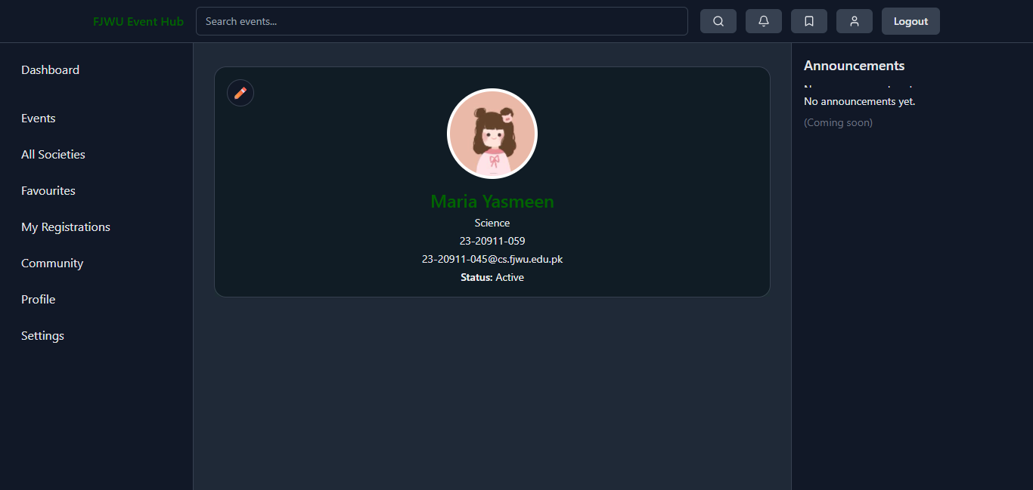- Student Edit Profile Page: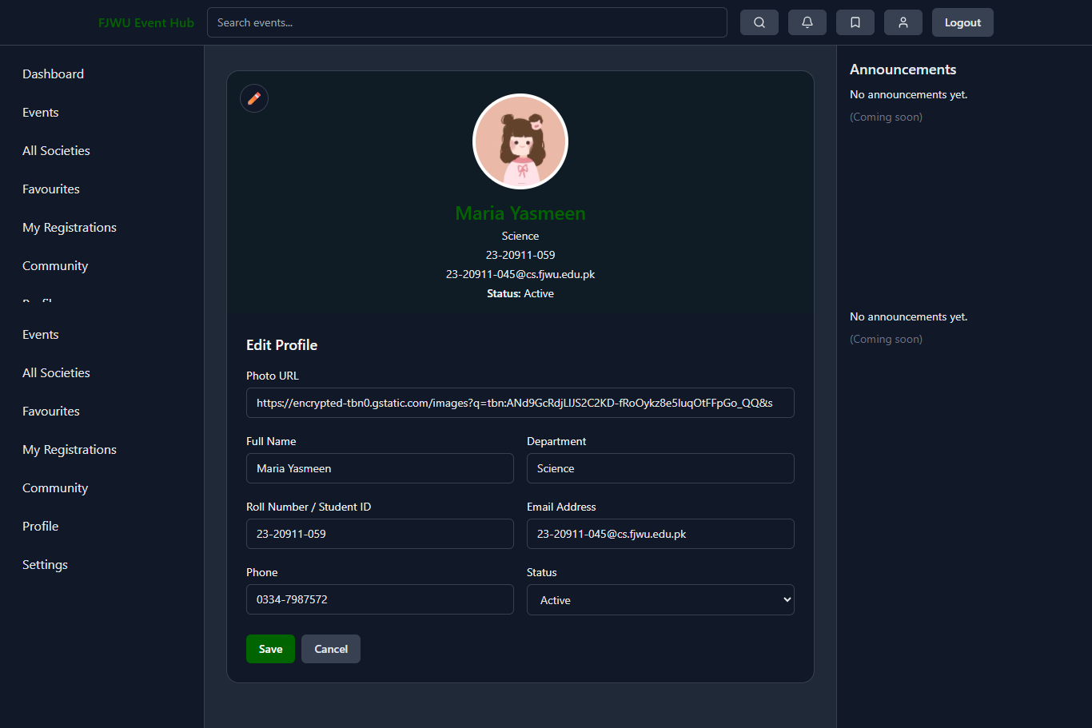

- Settings Page: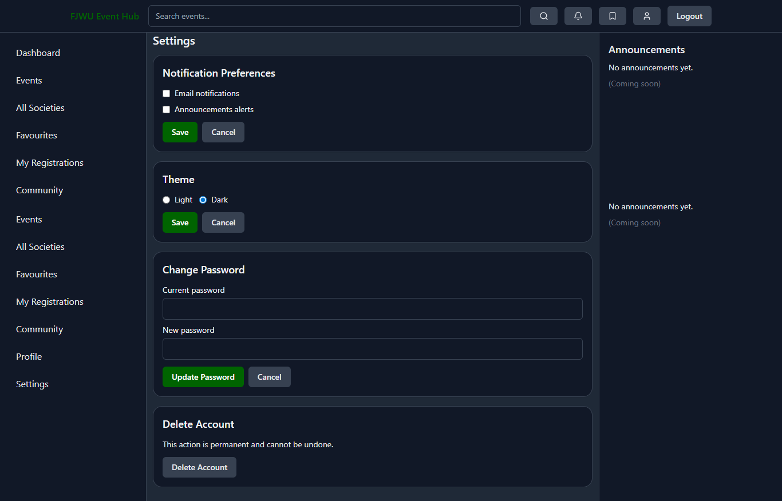
Manager Panel Screens

- Manager Dashboard (Home): The command center for society managers. It provides a statistical overview, displaying metrics like "Total Events Created," "Upcoming Events," and "Total RSVPs" to help track engagement.
- Create Event Screen:
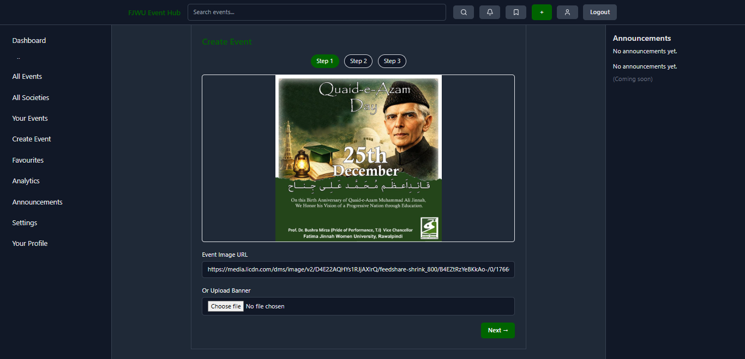
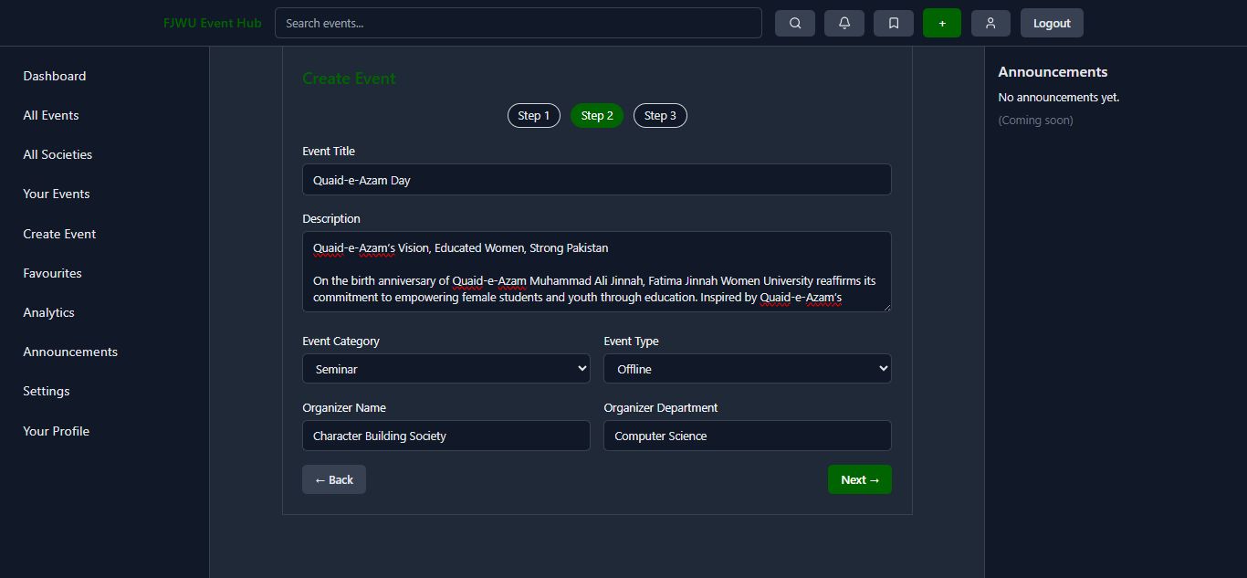
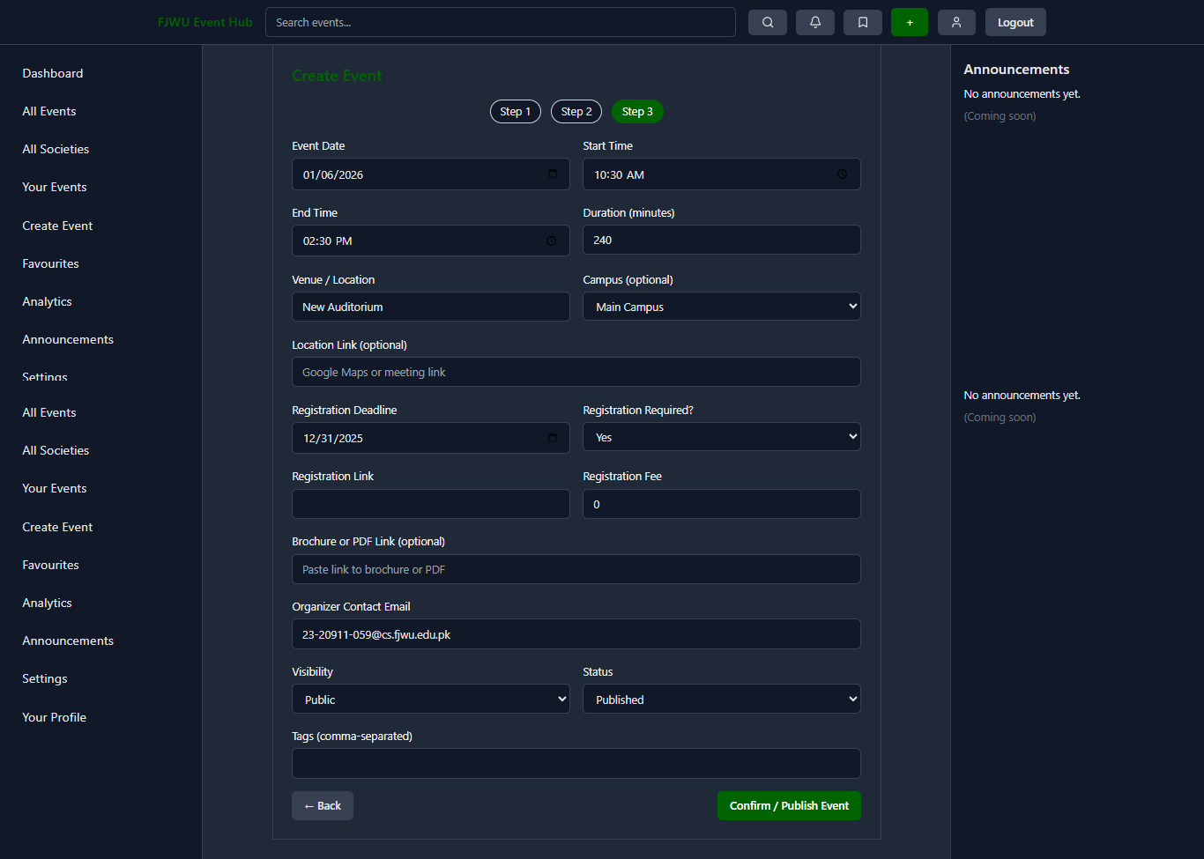
A detailed, multi-step form used to organize new events. Managers input core details (Title, Description), scheduling info (Date, Time), venue specifics, and registration requirements. It also supports uploading high-quality promotional banners.
- Event Manager All Events Screen: 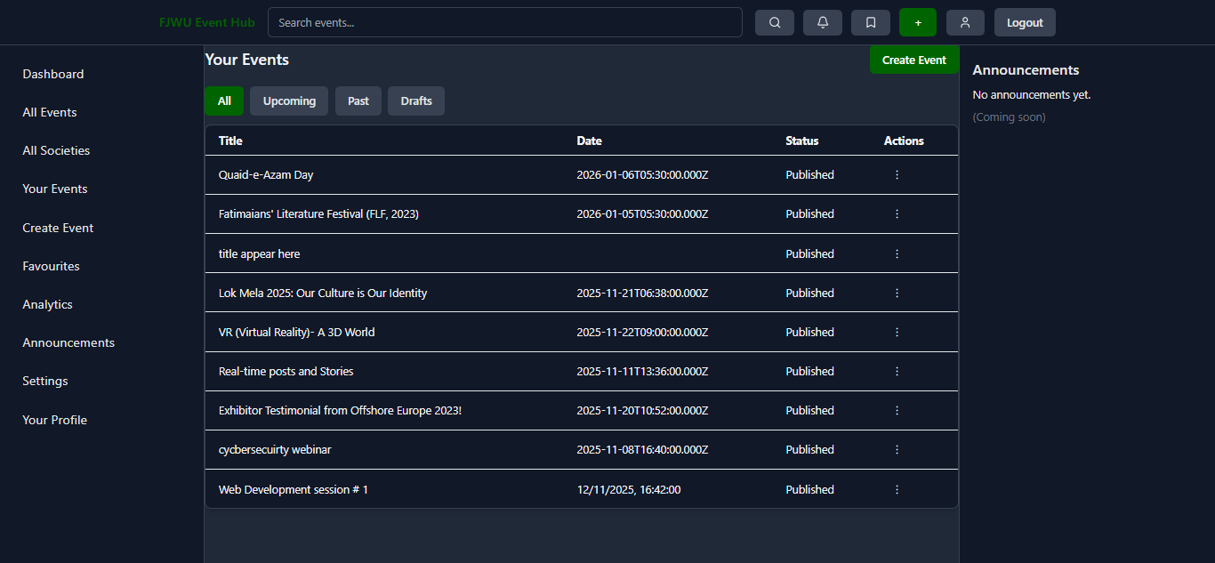A management table listing all events created by the manager. It offers filtering options (Published, Draft, Past) and action buttons to Edit or Delete specific events.
- Event Manager Seetings Screen:
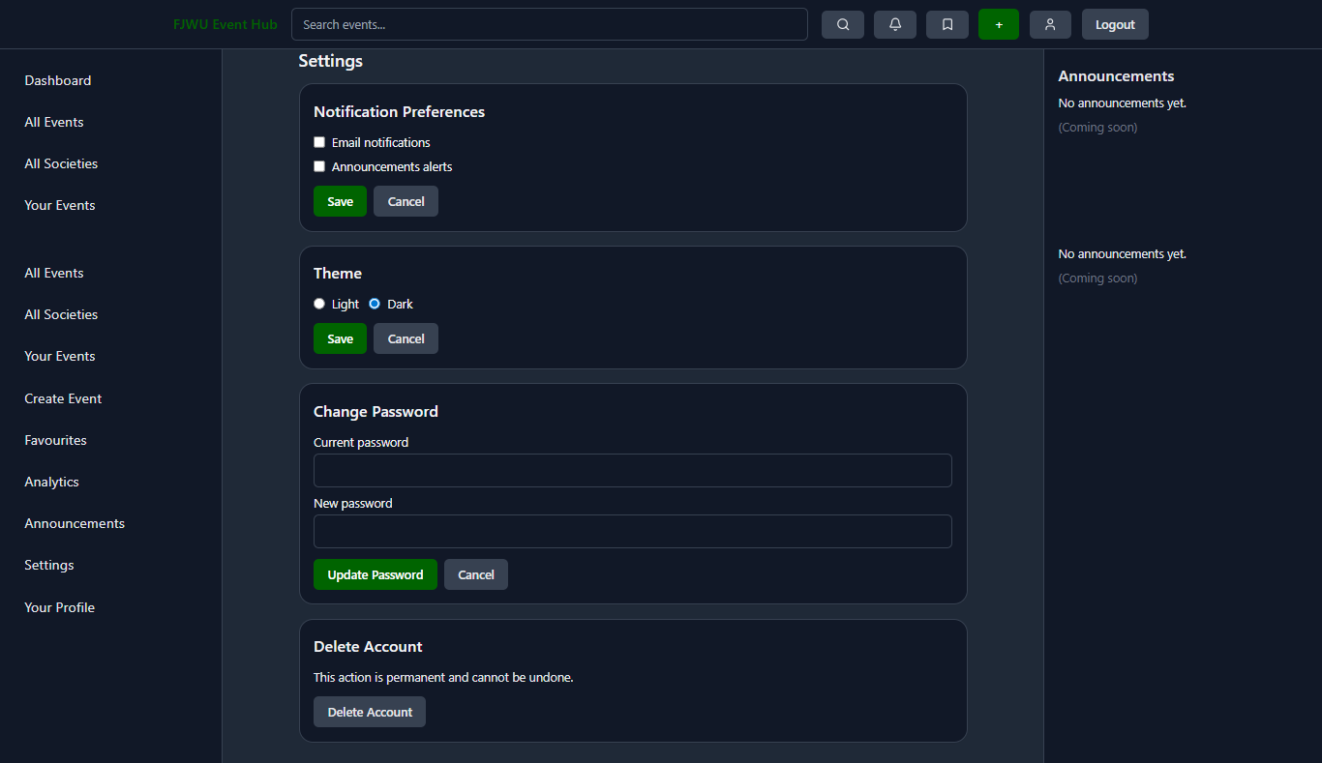
- Society Profile Screen (Event Manager Panel): 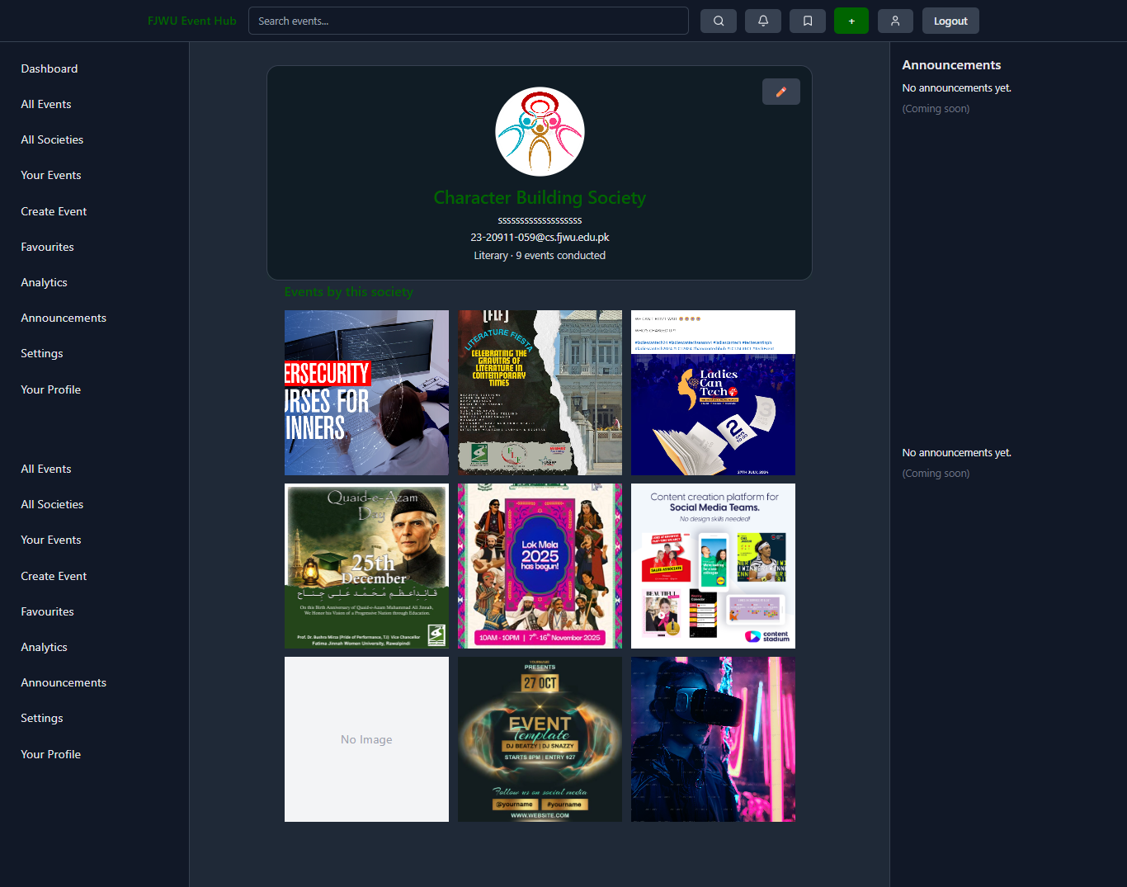Allows managers to establish their society's brand identity. They can upload a logo, set the official society name, write a description, and provide public contact information.
Common Screens
- All Events Screen: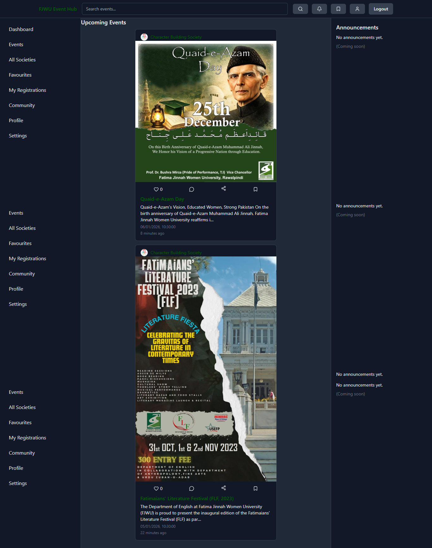
Event Detail Screen: The central information hub for any specific event. It displays the full event banner, detailed description, schedule, venue, and organizer information. It includes interactive elements like the "Register" button for students and a comments section for community discussion.
- All Registered Societies Screen:
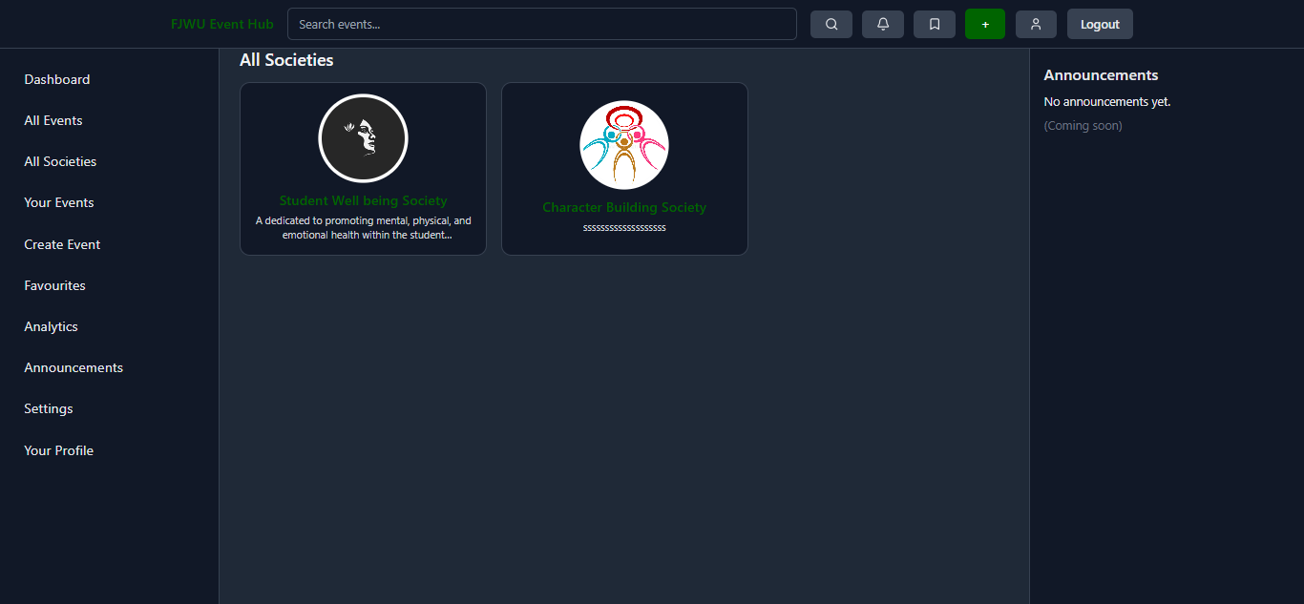
3. Routing: Upon login, the system detects the user's role. Managers are redirected to the Manager Dashboard, and Students to the Student Home.
4. Dashboard:
Student Dashboard:
- Students see a feed of upcoming events, which they can filter or search.
Manager Dashboard:
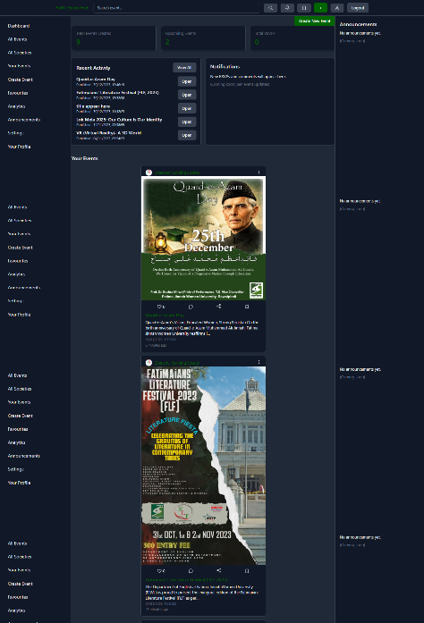
- Managers see an overview of their created events and tools to add new ones.
5. Action: A student clicks an event to view details and registers. A manager clicks "Create Event" to fill out a form and publish a new activity.

10. Features and Functionalities
* Authentication Module: Supports Sign Up, Login, and Logout. Crucially, it enforces a strict email validation rule allowing only domains ending in ".fjwu.edu.pk".
* Dashboard Views: Tailored views for Students (consumption-focused) and Managers (management-focused).
* Event Creation (Manager): A comprehensive multi-step form allows managers to input event title, description, date, time, venue, category, and upload a poster image.
* Event Feed (Student): Displays events in a card layout. Supports filtering by "Upcoming", "Past", and searching by keywords.
* Profile System: Users can view and edit their personal details, including Department and Semester.
* Favorites/Saved Events: Students can mark events as favorites for quick access (logic implemented in frontend filters).
* Image Uploads: Integration with Firebase Storage allows users to upload custom banners for events.

11. User Interface Design
The UI is designed with a "Clean and Modern" aesthetic using Tailwind CSS.
* Layout: The application uses a persistent sidebar navigation layout (LeftSidebar) ensuring users can always access key areas like Home, Events, and Profile.
* Responsiveness: Grid and Flexbox utilities ensure the layout adapts seamlessly to different screen sizes (mobile, tablet, desktop).
* Feedback: Loading spinners and error messages provide immediate system status feedback to the user.

12. Folder Structure and Code Organization
The codebase is organized logically within the `src` directory:
* components: Contains reusable UI elements like `EventCard`, `Navbar`, and `Sidebar`.
* pages: Contains top-level page components like `Login`, `Signup`, `Landing`, and `EventDetail`.
* panels: Divided into `manager` and `student` subdirectories, containing role-specific views (e.g., `ManagerEvents`, `StudentHome`).
* context: Houses `AuthContext.jsx`, which provides global user state throughout the app.
* routes: Contains `ProtectedRoute.jsx` for securing pages based on authentication status.
* utils: Helper scripts like `validators.js` (for email checking) and `storage.js` (for file uploads).
* assets: Static resources like images and icons.

13. State Management and Data Flow
* Global State: The application uses React's Context API (`AuthContext`) to manage the current user's authentication state and profile data. This ensures that user information is available to any component that needs it without prop drilling.
* Local State: Individual components use the `useState` hook to manage form inputs, loading indicators, and toggle states (e.g., opening/closing modals).
* Data Flow: Data is fetched from Firestore in parent components (like `EventFeed`) and passed down to child components (`EventCard`) via props.

14. Backend and Database Integration
* Firebase Firestore is the primary database.
* Data is structured into collections: `users` (storing profile info and roles) and `events` (storing event details).
* The application uses the Firebase Web SDK to perform CRUD (Create, Read, Update, Delete) operations directly from the frontend.
* `addDoc`, `getDocs`, `updateDoc`, and `query` functions are used to interact with the database.

15. Authentication and Authorization
* Authentication: Handled via `firebase/auth`. The system uses email/password authentication.
* Authorization: Implemented via the `ProtectedRoute` component. This wrapper checks if a user is logged in. It also checks the user's role (stored in the Firestore `users` profile) to prevent Students from accessing Manager pages and vice versa.
* Verification: A specific check ensures that the user's email is verified before granting access.

16. Error Handling and Input Validation

* Input Validation: The `validators.js` utility ensures email addresses match the university domain format. Forms check for required fields before submission.
* Error Handling: Try-catch blocks are used around asynchronous operations (like database fetches and login attempts). Errors are caught and displayed to the user via state variables (e.g., "Failed to load events").

17. Performance and Optimization
* React Hooks: `useEffect` and `useMemo` are used to prevent unnecessary re-renders and to handle side effects efficiently.
* Conditional Rendering: Components are only rendered when needed (e.g., loading states), improving perceived performance.
* Asset Optimization: The build process (via Vite) minifies and bundles code for faster load times.

18. Security Considerations
* Access Control: Route protection prevents unauthorized URL access.
* Data Security: While frontend logic restricts access, Firebase Security Rules (documented in `SECURITY_RULES.md`) typically enforce data integrity at the database level.
* Input Sanitization: React automatically escapes content, protecting against Cross-Site Scripting (XSS) attacks.
* Domain Restriction: Limiting registration to specific email domains acts as a first line of defense against external spam.

19. Testing and Execution
* Local Execution: The application is run locally using the `npm run dev` command, which starts the Vite development server.
* Testing Strategy: Testing is primarily manual during development, verifying that user flows (Login -> Create Event -> View Event) work as expected.
* Linting: ESLint is configured to catch code quality issues and potential bugs during development.

20. Deployment
The application is "build-ready" using `npm run build`. This generates a `dist` folder containing static files that can be deployed to any static hosting provider such as Vercel, Netlify, or Firebase Hosting. The presence of `capacitor.config.json` indicates readiness for deployment as a mobile application wrapper.

21. Limitations
* Offline Mode: While the app is web-based, full offline capability (PWA features) is not fully configured.

22. Future Enhancements
* Advanced Search: Implementing server-side search (e.g., Algolia) for better scalability.
* Community Features: Fully implementing the discussion forums for student interaction.
* Push Notifications: Using Firebase Cloud Messaging to notify students of new events.
* Calendar Integration: Allowing students to export events directly to their Google or Outlook calendars.
* Analytics Dashboard: Visualizing engagement data for managers (views, clicks, registrations).

23. Conclusion
The FJWU Event Hub is a robust, well-structured foundation for university event management. By leveraging modern web technologies and a serverless architecture, it solves the critical problem of information dissemination on campus. The clear separation of concerns between the Student and Manager interfaces ensures a tailored user experience. While currently in a functional prototype stage with some placeholder features, the core architecture is sound and ready for future scaling and feature expansion. It serves as an excellent example of a practical, real-world application of React and Firebase.

